Design and implement a simple inventory central system for w small video rental store using constructors and Object List

package vid;

import java.util.Scanner;

public class VideoMain {

public static void main(String args[]) {

VideoMethods mm = new VideoMethods();

while (true) {

System.out.println("%%%%%%%% VIDEO LIBRARY CENTER %%%%%%%%");

int n;

Scanner in = new Scanner(System.in);

System.out.println("1.ADD MOVIES");

System.out.println("2.DISPLAY MOVIES");

System.out.println("3.RENT OUT");

System.out.println("4.COLLECT BACK ");

System.out.println("PLEASE ENTER YOUR OPTION");

n = in.nextInt();

switch (n) {

case 1:

mm.AddMovies();

break;

case 2:

mm.DisplayAll();

break;

case 3:

System.out.print("Enter the movie you want to rent.");

in.nextLine();

if (mm.RentOut(in.nextLine())) {

System.out.println("Rent out successfull");

} else {

System.out.println("Sorry!! Not Available");

}

break;

case 4:

System.out.println("Enter the name and the ratings of the movie");

in.nextLine();

mm.CollectIn(in.nextLine(), in.nextDouble());

break;

}

}

}

}

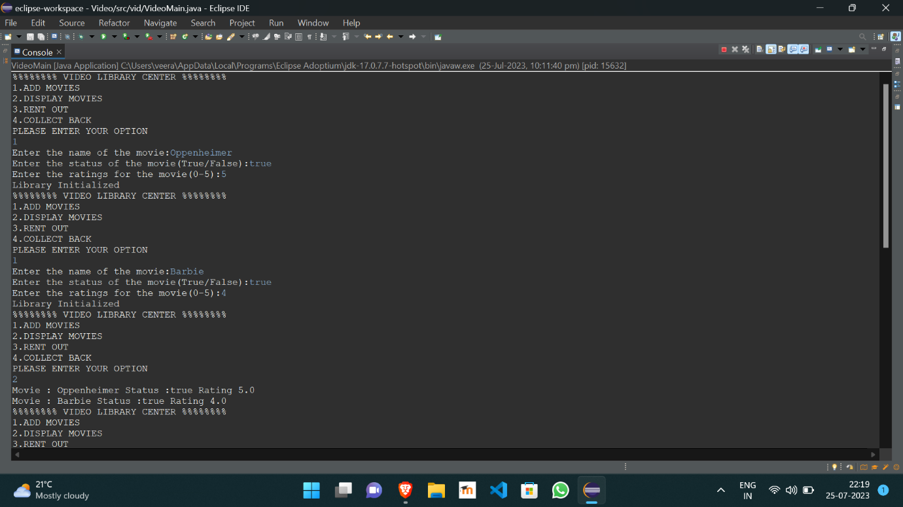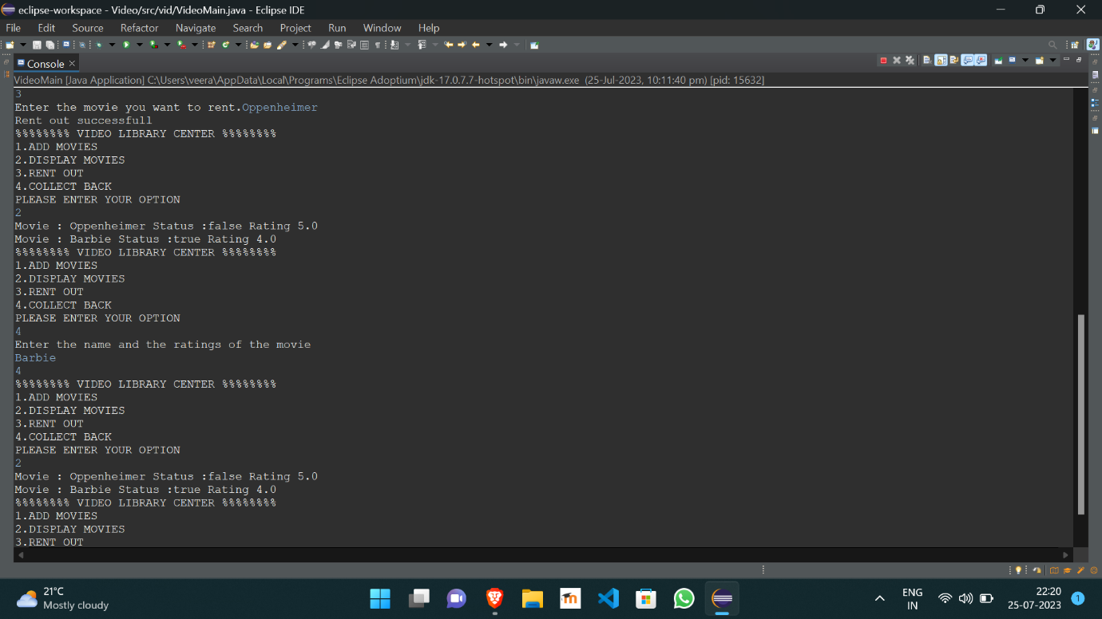

https://github.com/Veeragoutham04/Java_Lab/blob/main/Video